Working with indentation in text blocks

Indentation in text blocks is easy to understand if we have a clear picture of two terms:
- Incidental (or unessential) white spaces – represent the meaningless white spaces that result from code formatting (leading white spaces commonly added by the IDE) or are added intentionally/accidentally at the end of the text (trailing white spaces)
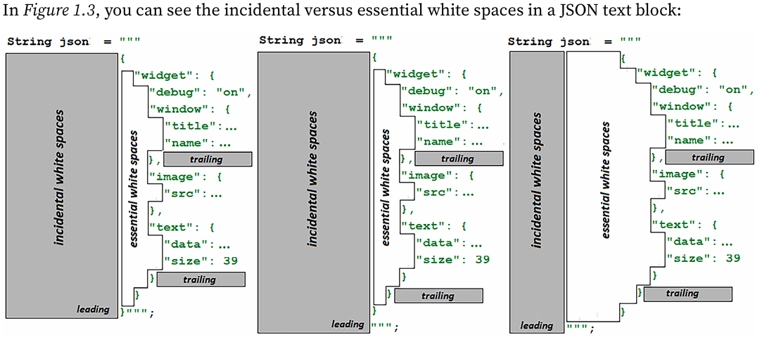
- Essential white spaces – represent the white spaces that we explicitly add, which are meaningful for the final string

The essential white spaces are preserved in the final string. Basically, as you can intuit from the previous figures, the essential white spaces can be added in two ways, as follows:
- By shifting the closing delimiter left (when this delimiter is on its own line)
- By shifting the content right (by explicitly adding white spaces or by using helper methods dedicated to controlling indentation)

Using indentation methods
We can add essential white spaces to a literal string via the String.indent(int n) method, where n represents the number of white spaces. This method can also be applied to indent the whole content of a text block, as follows:
String json = """
--------------********{
--------------********++"widget": {
--------------********++++"debug": "on",
--------------********++++"window": {
--------------********++++++"title": "Sample Widget 1",
--------------********++++++"name": "back_window"
--------------********++++},
--------------********++++"image": {
--------------********++++++"src": "images\\sw.png"
--------------********++++},
--------------********++++"text": {
--------------********++++++"data": "Click Me",
--------------********++++++"size": 39
--------------********++++}
--------------********++}
--------------********}""".indent(8);

